**Simple To Do List App using Microsoft Xamarin Form**

**Research Goal**

* *What is research topic*

People may and will forget about things and chores they need or even must to do, and when they do forget them, they will lose valuable time because the chore and things are unplanned now and have less time to do them. The topic of this research is how can we make an app using Microsoft Xamarin Form that can help people reduce or even eradicate their forgetfulness by simply noting down their chore and plan in their smartphone. The UI must be intuitive so people can use the app naturally without much hassle. Simply noting down one plan is not enough so the app must accommodate people with multiple plans.

* *Goal of research?*

Create an App that has intuitive UI that can help people plan ahead by noting down their plan and create list of their plans, then when they’re done, they can delete particular plan from the list or simply marking them as done.

**Description of topic**

* *Definition*

This is an Android based app that use Microsoft Xamarin Platform for its development. The goal of this topic is to find the best suitable intuitive UI for to do list app. Often to do list app has unintuitive UI thus make people having a hard time using it or rather not comfortable. This app uses simple UI so people can use it at ease.

* *Features*

This app is created using Microsoft Xamarin Form so it can be deployed on multiple platform (UWP, IOS, and Android), although in this research project, researcher only make it available on Android platform. This App is using SQLite to save entry to database.

This app can save multiple plan to database and then show them as list. This app can also delete “done” plan or simply mark them as done and don’t delete them from database.

* *Common usage*

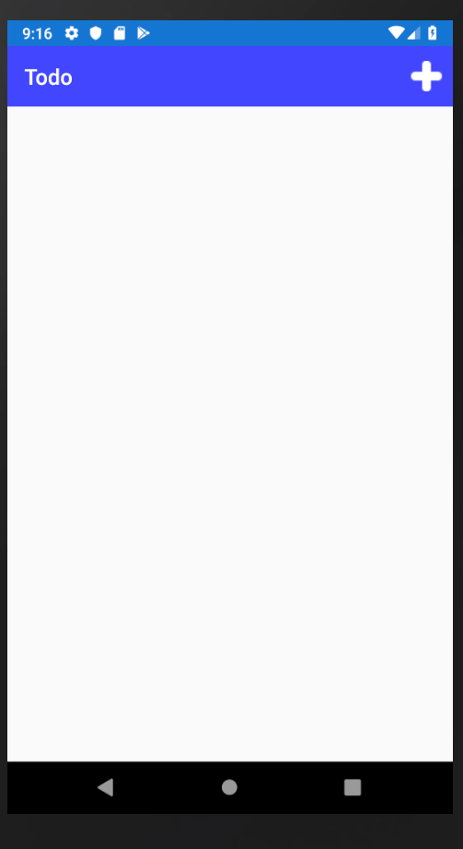

To add plans simply press the plus button on the top right corner of the screen.

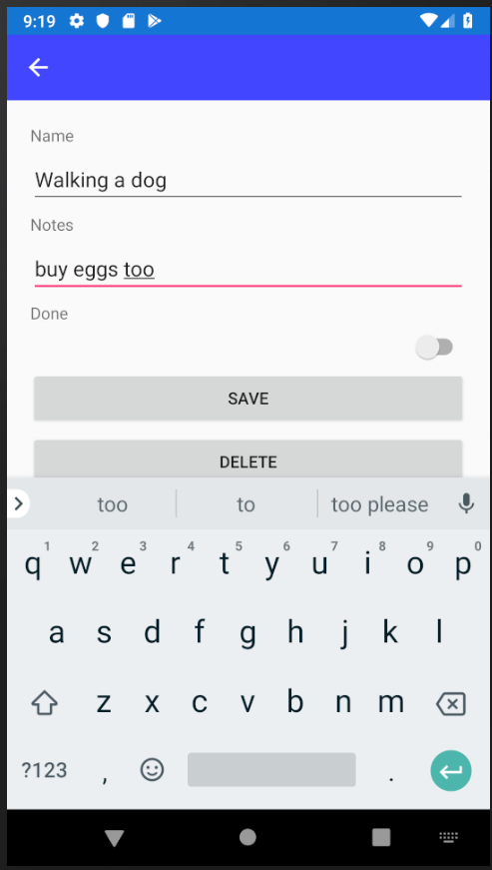

Then simply type the name of the plan and add notes if necessary. Then tap save when you’re done.

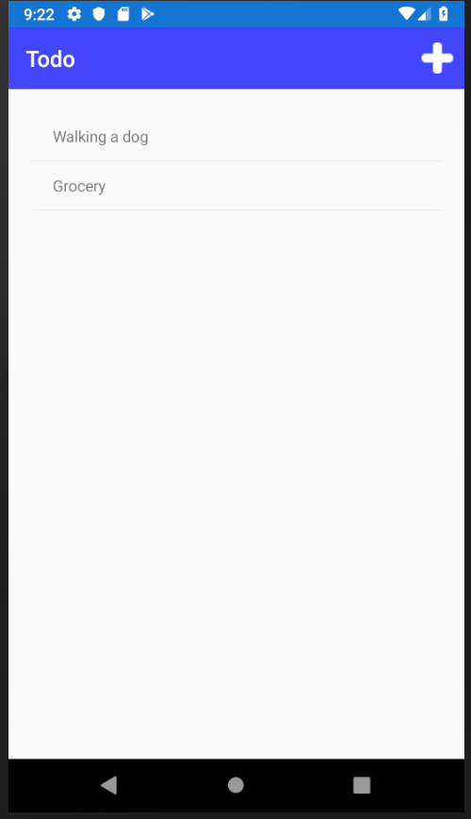

The saved plans then will be showed on to do list. You can edit plan by tapping the name plan.

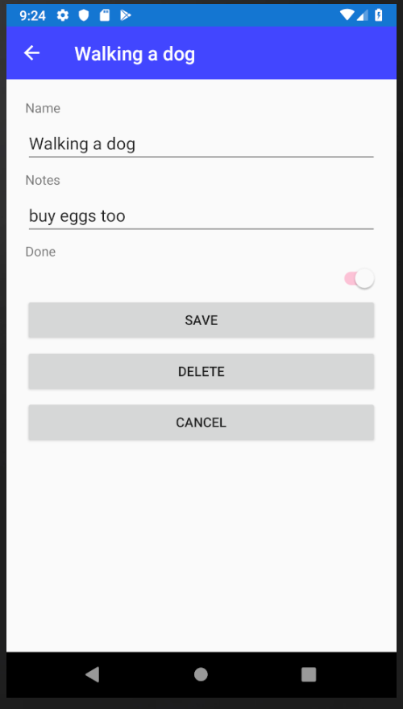

If your plan is done you can mark as so by toggling the Done switch. To delete just tap delete.

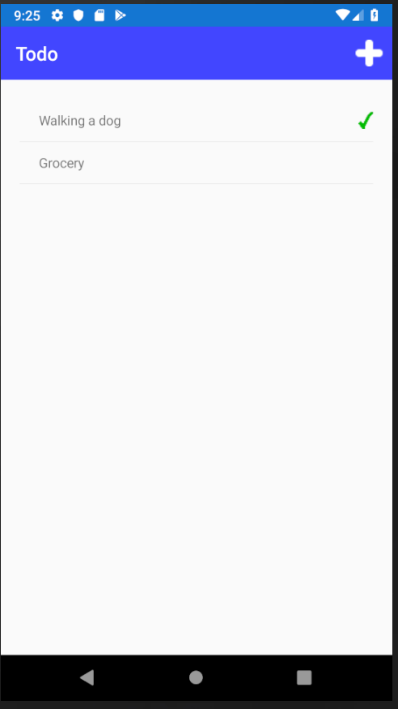

The plan then will be marked as done in to do view list.

* *Advantages* 
  + Can hold multiple plans and adding notes to them
  + Can simply mark the plans as done.
  + Intuitive UI so it can be used at ease
* *Disadvantages* 
  + Still not using calendar.
  + The UI too minimalistic.
  + Alarm not implemented.
* *Suggestion or idea for improvements*
  + Adding calendar.
  + Adding alarm chime.
  + Create Splash screen.
  + Toggling plans are done from to do list view.
* *Conclusion*

Researcher aknowledges that this app is far from ideal, but in the future this app will be further developed by adding calendar, alarm, and more features to it. In the meantime, hopefully this app can help people manage their time wisely and plan ahead. The last sentence is not only for reader but also for researcher himself.